Brendan Baronia

Melinda Ong

CPE 329-01

Assignment 3: LCD Display

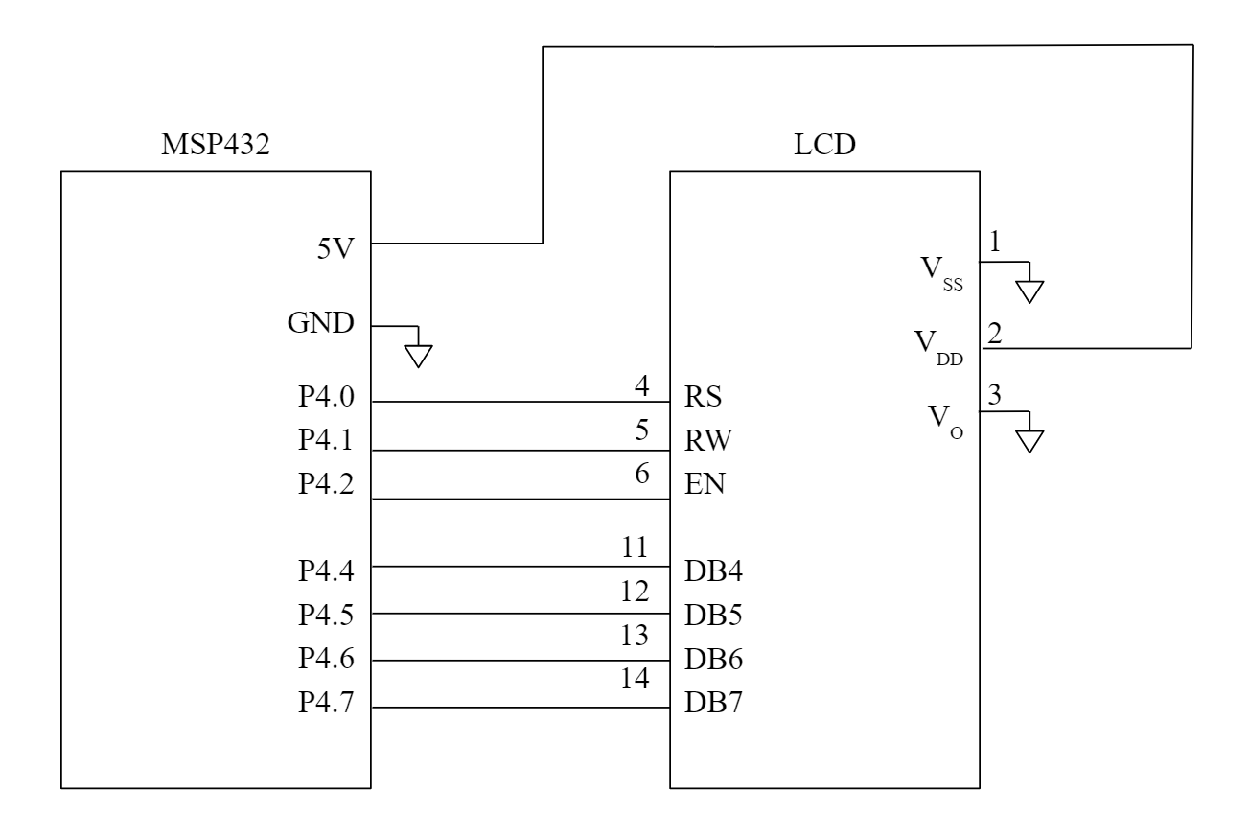

**Figure 1: Wiring Diagram for connecting the LCD to the MSP432 using 4-bit (nibble mode)**

1. The minimum amount of time necessary for the LCD to power on is 3.7μs.
2. 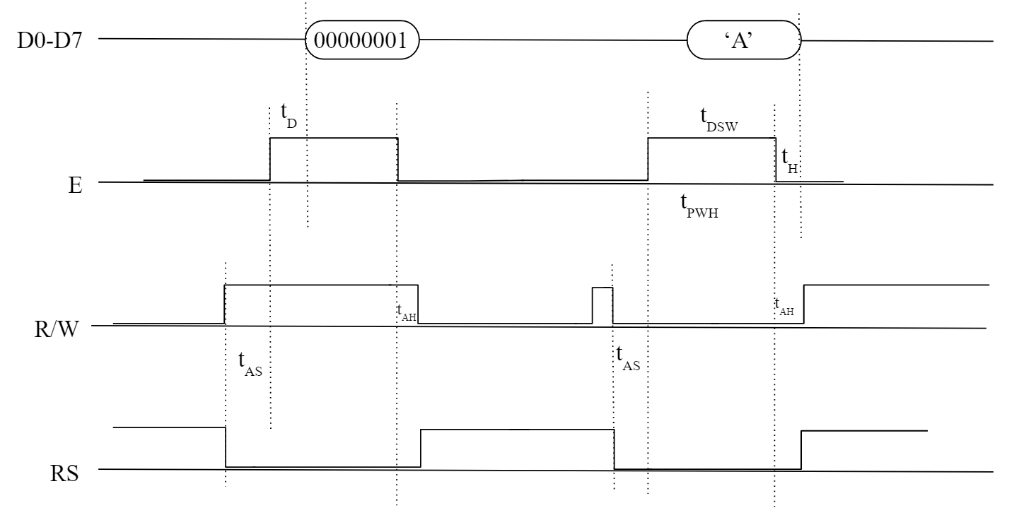  
   **Figure 2: Timing Diagram for clearing the LCD and displaying the letter A**
3. Source code for a function that will clear the LCD display:

/* clear the LCD display */

void Clear_LCD(){

unsigned char data = 1 & 0xF0;

unsigned char control = 0;

data &= 0xF0; /* clear lower nibble for control */

control &= 0x0F; /* clear upper nibble for data */

P4->OUT = data | control; /* RS = 0, R/W = 0 */

P4->OUT = data | control | EN; /* pulse E */

delayMs(0);

P4->OUT = data; /* clear E */

P4->OUT = 0;

delayMs(4);

data = 1 <<4;

data &= 0xF0; /* clear lower nibble for control */

control &= 0x0F; /* clear upper nibble for data */

P4->OUT = data | control; /* RS = 0, R/W = 0 */

P4->OUT = data | control | EN; /* pulse E */

delayMs(0);

P4->OUT = data; /* clear E */

P4->OUT = 0;

delayMs(1);

}

1. Source code for a function that will move the cursor to the home position of the LCD without clearing it:

/* move the cursor to home position without clearing */

void Home_LCD(){

unsigned char data = 0x80;

unsigned char control = 0;

data &= 0xF0; /* clear lower nibble for control */

control &= 0x0F; /* clear upper nibble for data */

P4->OUT = data | control; /* RS = 0, R/W = 0 */

P4->OUT = data | control | EN; /* pulse E */

delayMs(0);

P4->OUT = data; /* clear E */

P4->OUT = 0;

delayMs(4);

data = 0;

data &= 0xF0; /* clear lower nibble for control */

control &= 0x0F; /* clear upper nibble for data */

P4->OUT = data | control; /* RS = 0, R/W = 0 */

P4->OUT = data | control | EN; /* pulse E */

delayMs(0);

P4->OUT = data; /* clear E */

P4->OUT = 0;

delayMs(1);

}